Directions: The goal of the following problems is to help challenge and deepen your understanding of the current topic. Don’t assume that you will know how to answer each and every question. You will work with at least two other students in the class to try and find solutions and write arguments for each of the following questions. Be sure that you question your classmates’ reasoning. If you don’t understand how they are getting something you should ASK THEM TO EXPLAIN! Being able to defend your reasoning is important and so you are actually helping them by asking them to explain.

Challenge Questions

- Find the equation of the line tangent to the given curve at the point .

- True or False? The tangent line to the function (shown below) is horizontal when .
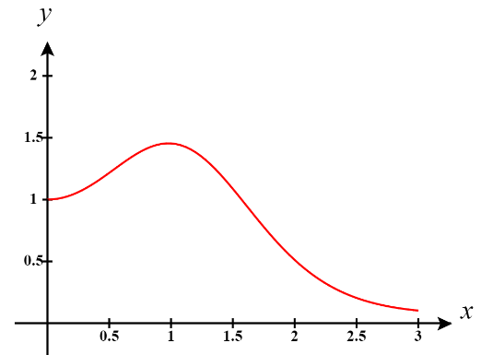

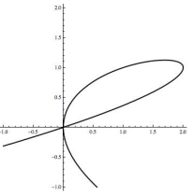
- The following is the graph of . There are two points on the graph where . Determine the equation of both tangent lines to the graph where .

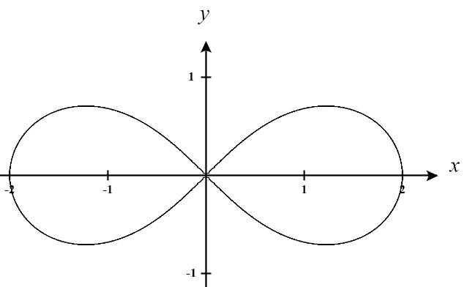
- The lemniscate shown below is described by the equation and is used in typography to denote infinity
- Find for points on the graph.

- Are there any points on the curve for which is undefined? If so, find all such points.

- Determine the equation for the tangent line at the point

- Consider a circle centered at the origin with radius r.

- If , show that the tangent line at the point is perpendicular to the radius of the circle.

- Show that for a circle of any radius that the tangent line at the point is perpendicular to the radius of the circle.

